Project Design
Proposed Solution
Date | 02 October 2026
Student Name | Dhanyaa V S
Project Name | Automated Network Request Management in ServiceNow

1. Problem Statement &amp; Enterprise Operational Bottlenecks
In traditional IT operating environments, provisioning network services—such as allocating fresh LAN drops, configuring high-speed VLANs, modifying active port bindings, and managing corporate bandwidth allocations—is heavily hindered by manual and decentralized workflows. Requests are typically submitted through unstructured emails sent to shared helpdesk inboxes, verbal requests in chat channels, or physical paper-based requisition slips. This fragmented intake mechanism creates substantial administrative blind spots for both the end user and system administrators.
Requesters face an opaque lifecycle with zero real-time visibility into the review status of their tickets. Without automated notifications, users are forced to send manual follow-up emails, resulting in communication overhead and heightened anxiety around missing project deadlines. Concurrently, IT administrators and network engineers spend excessive operational hours triaging incomplete tickets, manually reaching out to users to obtain missing parameters (such as physical installation addresses or connection identifiers), and coordinating managerial approvals. This administrative lag causes severe configuration backlogs, increases human error during manual record entry, and compromises adherence to organizational network security policies.
2. End-to-End Solution Architecture & Technical Design
To solve these operational challenges, an automated Network Request Management system was architected and deployed on the ServiceNow cloud platform. The solution provides a unified digital entry point, dynamic input validation, structured backend persistence, and low-code workflow automation executing a strict 10-step lifecycle.

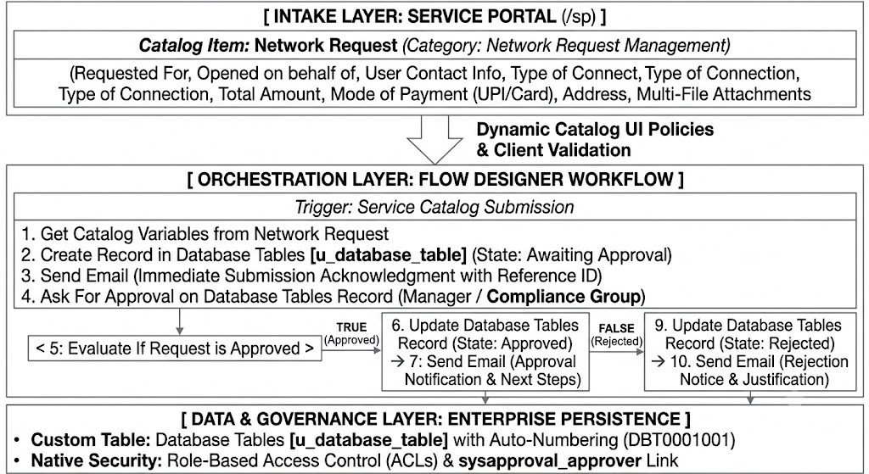

3. Detailed Implementation Modules
A. Self-Service Intake & Dynamic Catalog Design
Built within the ServiceNow Service Catalog under the ‘Network Request Management’ category, accessible via the Service Portal (/sp). The interface captures comprehensive user context including Requested For, Opened on behalf of, User Name, Phone Number, Email ID, and Mobile Number. A Multiple Choice selection captures the Type of Connection (New or Existing). Catalog UI Policies dynamically evaluate user selections in real time, automatically displaying the ‘Existing ID’ field only when ‘Existing’ is selected. Additionally, radio options capture the Mode of Payment (UPI or Card), along with a Total Amount field, physical installation Address, and a drag-and-drop file attachment component for network layout diagrams or authorization documents.
B. Structured Persistence in Custom Database Table
Submitted catalog variable values are mapped directly into a dedicated custom table: Database Tables [u_database_table]. This isolates network operational records from standard incident queues and enables custom schema definitions. The table features an automated numbering format (e.g., prefix ‘DBT’ with 7- digit auto-numbering), detailed work notes logging, and a direct relational link to the native approval engine (sysapproval_approver) to maintain clear historical tracking.
C. Automated 10-Step Flow Designer Execution Logic
The workflow eliminates manual administrative coordination through an asynchronous Flow Designer implementation:
• Trigger: Automatically initiates upon Service Catalog submission.
• Step 1 (Get Catalog Variables): Extracts all user parameters from the catalog item into workflow data pills.
• Step 2 (Create Record): Inserts a new record into Database Tables [u_database_table] with state set to ‘Awaiting Approval’.
• Step 3 (Send Email): Dispatches an immediate confirmation email to the user containing the reference record number.
• Step 4 (Ask For Approval): Automatically routes an approval request to the appropriate manager or network security team.
• Step 5 (Decision Branch): Evaluates whether the approval was granted.
• Steps 6 &amp; 7 (Approved Path): Updates the record state to ‘Approved’ and sends a confirmation email to the requester.
• Steps 9 &amp; 10 (Rejected Path): Updates the record state to ‘Rejected’ and notifies the user with relevant feedback.

4. Comprehensive Solution Evaluation

Dimension | Strategic Focus | Operational Implementation in ServiceNow
Novelty & Uniqueness | 100% Low-Code Architecture | The system achieves full lifecycle automation using native Flow Designer actions rather than complex, brittle custom scripts. Dynamic client UI policies enforce data consistency at the point of entry, and native integration with sysapproval_approver provides complete audit transparency.
Customer Experience & Social Impact | Eliminating Anxiety & Friction | Requesters receive immediate email receipts upon submission and real-time status updates at every stage. Turnaround times drop from days to hours, preventing project delays for students and engineers while eliminating repetitive manual follow-ups.
Business Model & Cost Recovery | Resource Optimization & Chargeback | Significantly reduces manual triage overhead for network staff, allowing them to focus on high-priority infrastructure and security tasks. Integrated payment details (UPI/Card and Total Amount) enable clear chargeback models across internal departments or external clients.
Scalability & Future Integration | Enterprise Cloud Expansion | Built on the resilient ServiceNow multi-instance architecture, effortlessly scaling to thousands of concurrent requests. Designed for modular integration: the flow can connect directly to network orchestrators (Cisco DNA Center, Ansible) via Integration Hub for zero-touch automated provisioning.

